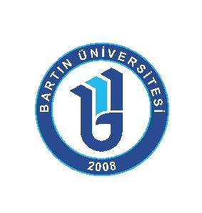

BARTIN ÜNİVERSİTESİ

- Institutional Details

Full Legal Name | Bartın Üniversitesi / Bartın University
OID (Organzation ID) | E10169843
PIC | 944273079
Promoter’s legal name | Bartın University
Address | Bartın Üniversitesi Kutlubey Yerleşkesi Kutlubeyyazıcılar Köyü Yeni Köybağlısı Yeni Sokak No:32/2 Posta Kodu:74100 Merkez/Bartın
Country | TÜRKİYE
City | 74100 BARTIN
Web Page | https://erasmus.bartin.edu.tr
Email | ulik@bartin.edu.tr / international@personel.bartin.edu.tr
Telephone | +90 378 223 54 35 - +90 378 223 54 37 - +90 378 223 54 38
Accreditation  (Accreditation Reference Number) | Erasmus Code: TR BARTIN01  ECHE: 253592-EPP-2014-1-TR-EPPKA3-ECHE  ESC Quality Label: ESC-2019/32

- Legal Representative

Rector | Prof. Dr. Ahmet AKKAYA
Address | Bartın Üniversitesi Kutlubey Yerleşkesi Kutlubeyyazıcılar Köyü Yeni Köybağlısı Yeni Sokak No:32/2 Posta Kodu:74100 Merkez/Bartın
Email | aakkaya@bartin.edu.tr
Telephone | +90 378 223 55 00

- Main Contacts

Contact Person | Prof. Dr. Yafes YILDIZ
Responsibility | Vice Rector for International Relations
Contact Details | Bartın Üniversitesi Kutlubey Yerleşkesi Kutlubeyyazıcılar Köyü Yeni Köybağlısı Yeni Sokak No:32/2 Posta Kodu:74100 Merkez/Bartın  email: yyildiz@bartin.edu.tr
Main Contact Person | Asst Prof Dr Ahmet Yirmibeş
Responsibility | Erasmus Institutional Coordinator
Contact Details | Bartın Üniversitesi Kutlubey Yerleşkesi Kutlubeyyazıcılar Köyü Yeni Köybağlısı Yeni Sokak No:32/2 Posta Kodu:74100 Merkez/Bartın  Phone: +90 378 223 54 36  Email: ayirmibes@bartin.edu.tr
Contact Person | Cihan Bozkurt
Responsibility | Erasmus Office Administrative Staff
Contact Details | Phone: +90 378 223 54 35  Email: cbozkurt@personel.bartin.edu.tr
Contact Person | Murat İpek
Responsibility | Instructor
Contact Details | Phone: +90 378 223 5438  Email: mipek@bartin.edu.tr
Contact Person | Dr Esra Eroğuz
Responsibility | Instructor
Contact Details | Phone: +90 378 223 54 37  Email: eeroguz@bartin.edu.tr
Contact Person | Kardelen Yaman
Responsibility | Instructor
Contact Details | Phone: +90 378 223 54 23  Email: kyaman@bartin.edu.tr

- About Bartın University
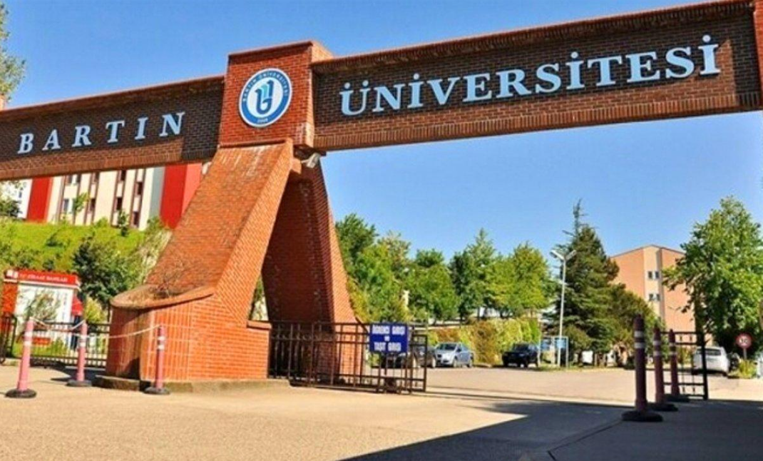

Founded on 22 May 2008 with Law No. 5765, Bartın University committed itself to educate individuals, who are devoted to learning, research, and production, critical thinking, who develop their critical thinking, cooperating and problem-solving skills, who possess scientific and ethical values, and who will shape the future of our country, by providing students a modern learning and science environment, and contribute to the life-long education and development process of the society. By this mission, our university gives great importance to the fields of culture, health, and sports of the youth.
In the light of the innovations made in the field of education in the European Union process, Bartın University committed itself to contribute to the cultural and academic development of the students and works with a great motivation to fulfill the mission of developing new projects with the European Union financing.
Today, Bartın University has around 18000 students at nine faculties, three vocational schools, a graduate school, and a foreign language school. In terms of its internationalization policy, our institution seeks to produce scientific knowledge and innovation by establishing new partnerships and cooperation at the European and international levels.

- Recommended Language Skills

The sending institution, following an agreement with our institution, is responsible for providing support to its nominated candidates so that they can have the recommended language skills at the start of the study or teaching period:

Type of mobility | Subject Area | Languages of Instruction | Recommended language of instruction level
Student Mobility for studies | Any | Turkish or English | B1
Staff Mobility for Teaching | Any | Turkish or English | B1
Staff Mobility for Learning | Any | Turkish or English | B1

- Accommodation

Bartin University (BARU) does not provide accommodation. However, there are several options.
Option 1: private student dorms/apartments in the city center. The prices are around 10000-15000 Turkish Lira (TL) (about 200-300 euro) per month. The price varies according to the type of room- single use, double or triple. They cover heating, electricity, and the internet.
Option 2: Renting an Independent Flat/Apartment in the city center or near the campus. The prices are around 1500-2000 TL (300-400 euro per month) according to the location, furniture, etc. The cost of rent does not cover electricity, heating, etc. The approximate electricity bill could be around 500 TL, and heating in winter could be about 1000 TL per month.
*According to your preference, we can share the details and websites of the private dorms or some flats for rent. We will be supporting you in every step.

- Travel to Bartin City (BARTIN / Bartın)

Option 1 /
1a.From Germany to Zonguldak ONQ By Plane: Zonguldak Airport (ONQ) is only 30 km awat from Bartin city center. There are direct flights from Dusseldorf to Zonguldak Airport (ONQ) with Corendon Airlines and Sunexpress Airlines. This option may be more expensive than the others.
1b. Domestic Flight from Istanbul to Zonguldak ONQ: There are also scheduled domestic flights from Istanbul Airport to ONQ three times a week operated by Turkish Airlines. The prices depend on the season or the time of booking, but the approximate costs are around 1000-1500 TL (30euros).
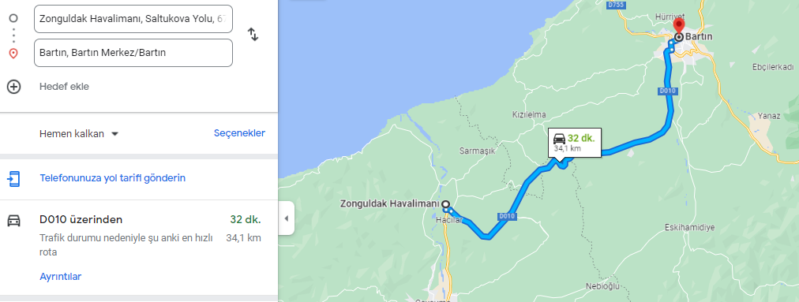

Option 2 / Bus From Istanbul to Bartın: The central bus station in Istanbul is Esenler Otobus Terminali (Esenler Bus Station). There are direct shuttles from Istanbul Airport to Esenler Bus Terminal. According to the company, travel by bus to Bartın may take around 5-7 hours. The buses are comfortable. Online booking or buying a ticket is possible. The bus companies are KAMIL KOC, METRO, EFETUR, and KALE TUR. The approximate price is around 700- 900 TL (14-18 euro)
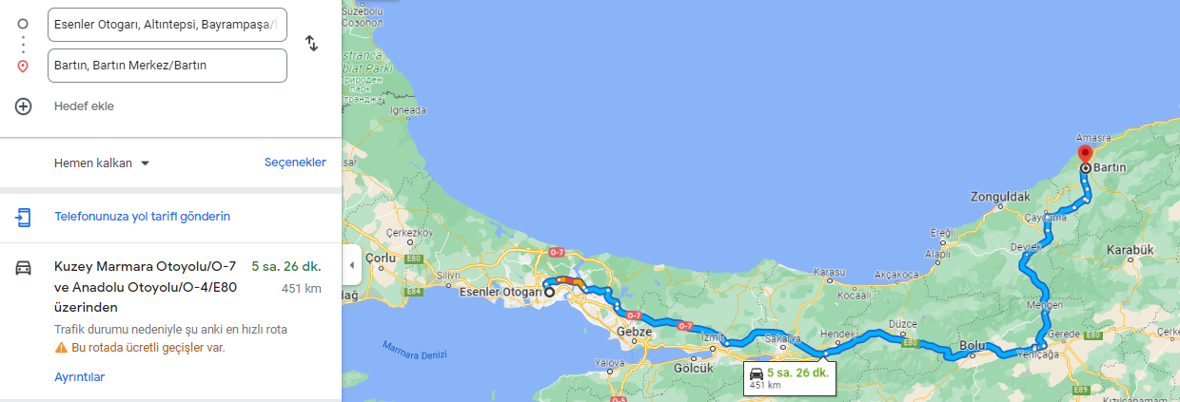

- Health Insurance

Option 1: State Insurance/ General Social Health Insurance. It covers all treatment, operations, etc., in all state hospitals in Turkey. In 2025 the price was 1500TL for a month.
Option 2: Private Insurance. You can get treatment in private hospitals at a reduced price. You can also go to state hospitals. However, you may need to pay some money. Private insurance prices were around 600-1000 TL (around 20 euros for the whole study period) in 2025.
*Emergency Service in any private or state hospital is free of charge regardless of insurance.
**IMPORTANT: We would like to inform you about the requirement of the Migration Office in Turkey. When you apply for a residence permit, they only accept a Turkish Version of the Insurance document. Thus, be sure that you can have a Turkish copy of the insurance if you have it in your country. Or, you can prefer to have it in Bartın /Turkey.

- Residence Permit

International students who stay for more than three months should apply for a residence permit within the first 30 days after they enter the country. BARU Erasmus Office will help you to complete your online application and paperwork. You must pay 1000 TL (20 euros) for the Resident ID card to the Migration Office online.

- Currency

The only currency used in Turkey is the Turkish Lira. One euro is 50 TL today. When you arrive at the airport, we suggest you change your money in the cash machines at the airport instead of Change Offices for a better benefit of changing rates.

- Useful Sites

Bartın University | https://w3.bartin.edu.tr/
Bartın Governorship | http://www.bartin.gov.tr/
Bartın Municipality | https://bartin.bel.tr/
Information About East Black Sea Region | https://www.bakka.gov.tr//bolgemiz/bati-karadeniz
Bartın Culture and Tourism Provincial Directorate | https://bartin.ktb.gov.tr/

